**Introduction to Mac OS**

* **Mac OS** is a series of [graphical user interface](https://en.wikipedia.org/wiki/Graphical_user_interface)–based [operating systems](https://en.wikipedia.org/wiki/Operating_system) developed by [Apple Inc.](https://en.wikipedia.org/wiki/Apple_Inc.) for their [Macintosh](https://en.wikipedia.org/wiki/Macintosh) line of [computer systems](https://en.wikipedia.org/wiki/Computer_system).
* The [original operating system](https://en.wikipedia.org/wiki/System_1) was first introduced in 1984 as being integral to the [original Macintosh](https://en.wikipedia.org/wiki/Macintosh_128K), and referred to as the "System".
* Referred to by its major revision starting with "System 6" and "System 7", Apple rebranded version 7.6 as "Mac OS" as part of their [Macintosh clone](https://en.wikipedia.org/wiki/Macintosh_clone) program in 1996.
* The Macintosh, specifically its system software, is credited with having popularized the early [graphical user interface](https://en.wikipedia.org/wiki/Graphical_user_interface) concept.
* Mac OS is the computer [operating system](http://searchcio-midmarket.techtarget.com/definition/operating-system) for Apple Computer's [Macintosh](http://searchcio-midmarket.techtarget.com/definition/Macintosh) line of personal computers and workstations.
* A popular feature of its latest version, Mac [OS X](http://whatis.techtarget.com/definition/OS-X) , is a [desktop](http://searchwinit.techtarget.com/definition/desktop) interface with some [3-D](http://whatis.techtarget.com/definition/3-D-three-dimensions-or-three-dimensional) appearance characteristics.
* OS X has a modular design intended to make it easier to add new features to the operating system in the future. It runs [UNIX](http://searchenterpriselinux.techtarget.com/definition/Unix) applications as well as older Mac applications.
* Mac OS comes with Apple Computer's [iMac](http://whatis.techtarget.com/definition/iMac) and Power Macintosh line of computers.

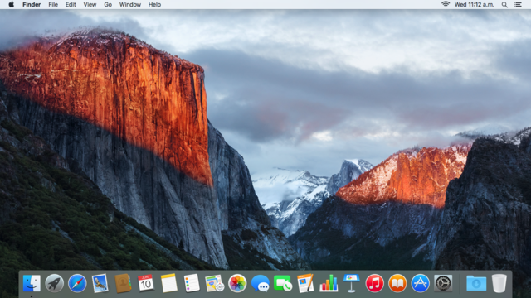

|  |  |
| --- | --- |
| [**Developer**](https://en.wikipedia.org/wiki/Software_developer) | [Apple](https://en.wikipedia.org/wiki/Apple_Inc.), [NeXT](https://en.wikipedia.org/wiki/NeXT) |
| **OS family** | [Classic Mac OS](https://en.wikipedia.org/wiki/Classic_Mac_OS) (System 1–7, Mac OS 8–9) [Unix](https://en.wikipedia.org/wiki/Unix), Mach and [FreeBSD](https://en.wikipedia.org/wiki/FreeBSD) ([OS X](https://en.wikipedia.org/wiki/OS_X))[[1]](https://en.wikipedia.org/wiki/Mac_OS#cite_note-leopard_unix_cert-1)[[2]](https://en.wikipedia.org/wiki/Mac_OS#cite_note-2)[[3]](https://en.wikipedia.org/wiki/Mac_OS#cite_note-3) |
| **Working state** | Publicly released |
| **Source model** | **Classic Mac OS:** [Closed source](https://en.wikipedia.org/wiki/Closed_source) **OS X:** [Closed source](https://en.wikipedia.org/wiki/Closed_source) (with [open-source](https://en.wikipedia.org/wiki/Open-source) components) |
| **Initial release** | **Classic Mac OS:** January 24, 1984; 32 years ago **OS X:** September 13, 2000; 15 years ago (as Mac OS X) |
| [**Latest release**](https://en.wikipedia.org/wiki/Software_release_life_cycle) | 10.11.3 (Build 15D21) / January 19, 2016; 23 days ago |
| [**Latest preview**](https://en.wikipedia.org/wiki/Software_release_life_cycle) | 10.11.4 Beta (Build 15E27e) / January 11, 2016; 31 days ago |
| [**Kernel**](https://en.wikipedia.org/wiki/Kernel_(computing))**type** | **Classic Mac OS:** [Monolithic](https://en.wikipedia.org/wiki/Monolithic_kernel) **OS X:** [Hybrid](https://en.wikipedia.org/wiki/Hybrid_kernel) ([XNU](https://en.wikipedia.org/wiki/XNU)) |
| [**License**](https://en.wikipedia.org/wiki/Software_license) | [Proprietary](https://en.wikipedia.org/wiki/Proprietary_software) |
| **Official website** | [apple.com/osx/](http://apple.com/osx/) |

[MacBook](http://www.apple.com/macbook/) Built-in Apps

# One of the best things about a Mac is everything you can do with it.

* Every Mac comes with a collection of great apps for things you do every day, like Safari for surﬁng the web, Photos for managing your photos and videos, Pages for creating documents, Numbers for making spreadsheets, and Keynote for preparing presentations.
* There are apps for sending email and text messages, taking notes, and staying up to date with your contacts and calendar. It even comes with the Mac App Store for finding new apps. Your Mac is more than fully featured, it’s fully loaded.

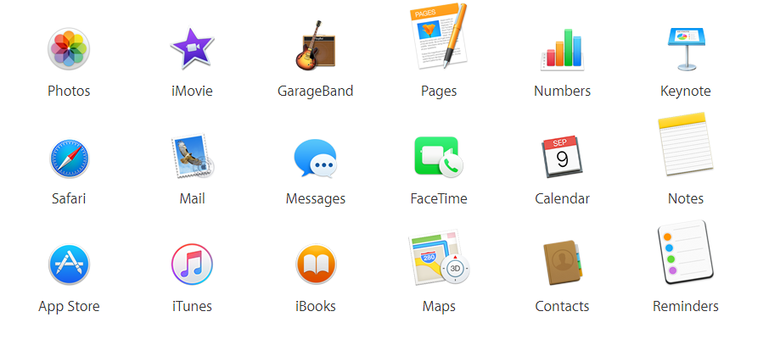



Safari is the best way to see the sites.

* Safari is the best, fastest, and most secure way to surf the web on your Mac, with all kinds of innovative features that make your browsing more enjoyable.
* Keep favorite websites open and accessible with Pinned Sites.
* Quickly mute audio without hunting for the tab it’s coming from.
* Use AirPlay to stream video from a web page to your HDTV with Apple TV.
* It’s also easy to share the cool pages you find.
* Just click the Share button to tweet, post to Facebook, or send to a friend.
* Energy-saving technologies let you surf longer. And built-in privacy features protect you from being tracked as you go.



## Get apps for your Mac from your Mac.

* The Mac App Store lets you browse, purchase, and install apps, widgets, and extensions on your Mac.
* New apps install in one step to Launchpad.
* If you get a new Mac, you can quickly re download all the apps you own.
* The Mac App Store can automatically update your apps and even OS X for you, so you always have the latest versions.
* You can browse Mac apps by category, such as games, productivity, music, and more. Or do a quick search for something specific.
* Read descriptions and customer reviews.
* Flip through screenshots.
* When you find an app you like, click to buy it.
* The Mac App Store has apps for just about everything and everyone.

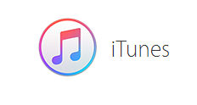

## Your music, movies, and TV shows take center stage.

* iTunes is home to a universe of entertainment right on Mac.
* It’s the best way to organize and enjoy the music, movies, and TV shows you already have, and shop for the content you want to get.
* Beats 1 — is free Apple Music worldwide radio station — for the latest music, interviews, and culture, 24/7.
* With an Apple Music membership, you can tune in to on-demand music stations with handpicked songs and artists based on what you listen to and like, and explore artists, albums, and genres you never knew you’d love.
* And membership gives you unlimited access to the more than 30 million songs in the Apple Music library.

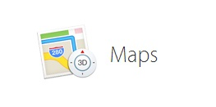

## A destination unto itself.

* By using Maps you will get the whole world on your desktop.
* Get information on local points of interest like restaurants and hotels, with phone numbers, photos, and Yelp reviews.
* You can look up transit, driving, or walking directions on your Mac and send them to your iPhone for voice navigation on the way.
* Navigating with Maps is incredibly smooth and responsive, and you get gorgeous views using Flyover, a photo-realistic, interactive 3D experience that lets you soar high above select cities.



## The last word in word processing.

* It is used make beautiful documents in Pages.
* Paint a picture with words. Or add a picture, movie, shape, or gorgeous chart.
* Tools for whatever you’re doing appear right when you need them in the context-sensitive format panel and when you’re ready to share your Pages document, you can simply send a link that anyone can open from any modern web browser on a Mac or PC.
* Writing has never been so effortless.



# The Finder organizes all of our files

* The Finder in OS X provides access to the files, folders, and drives on your Mac, and helps you keep them organized.
* The Finder is the app that helps you navigate all of the files and folders on Mac.
* The Finder lets you browse your apps, disks, files, and folders in a variety of ways.
* You can use the Finder to organize these items the way you want.
* You can also use the Finder to search for items, delete files you no longer want, and more.

## C:\Users\rnadaf\Desktop\Maps.jpg Spotlight

# Spotlight helps you find what you‘re looking for

* Spotlight helps you quickly locate files on your Mac, and more.
* Use Spotlight to search for things like apps, documents, images and other files.
* In OS X Yosemite, Spotlight suggestions offer additional results like Wikipedia, news sites, Maps, iTunes, movie listings, and more.
* To open Spotlight, click the magnifying glass icon in the upper-right corner of the menu bar, or press Command-Space from any app.
* Spotlight appears front and center when you open it.
* To search for something, type words related to it like an app name, a word contained in a document, or [a tag](http://support.apple.com/kb/HT202754) you've attached to a file.
* You can also search for items like a Wikipedia article, or the location of your nearest Apple Store.
* As you type, Spotlight auto completes the search field with suggestions. You don't have to finish typing to open a suggested item, just type the first few letters and press Return. It's a convenient way to quickly open your favorite apps.



## An app you’ll appreciate day after day

* Keep track of our busy schedule and share it with others using Calendar.
* Create separate calendars — one for home, another for school, a third for work, and so on. See all your calendars in a single window or choose to see only the calendars you want.
* The inspector lets you add a location to your event, suggests locations as you type, provides maps and weather forecasts, and automatically alerts you when it’s time to leave.
* And when you use iCloud, every Calendar change you make on your Mac automatically appears on your iOS devices and Apple Watch.3 So no dinner dates are missed, no meeting goes unattended, and no anniversary is forgotten.